Parenting is a very difficult task.
Parenting separately brings its own unique challenges.

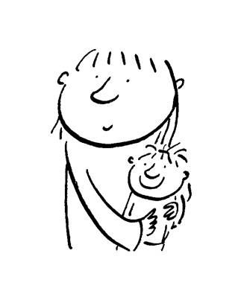
Family Matters York and York Family Mediation Service are offering a FREE 2-session course which explores some of these challenges and how we can do the best for our children.

Date: Thursdays 5 & 12 May 2016
Time: 7.30 to 9.30pm
Venue: Elim Corner, First Floor
47-49 Lawrence Street, York YO10 3BU
(above the Triumph Motorbike shop)

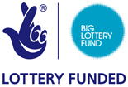
The course is free thanks to generous funding from Awards for All which is part of the Big Lottery Fund.

Ex-partners must attend the course separately.

To book a place or for any further information please contact Helen Atkinson on 789214, email helenatkinson@fmy.org.uk or Catharine Morris on 792151, email yorkfms@care4free.net

Come along and share your ideas with other parents!

